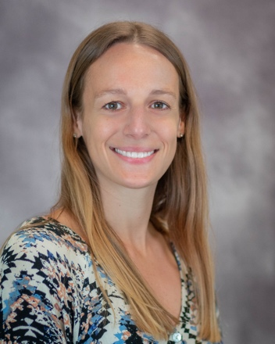

**Lauren Ott, Physician Assistant**

Lauren Ott is a physician assistant who has expertise in ambulatory hernia surgery. She is the co-founder of Boston Hernia based in Wellesley, Massachusetts.

She also serves on the Opioid Reduction Task Force of the Abdominal Hernia Society Quality Collaborative, which is working to reduce the impact that post-op prescribing has on the epidemic. Over the last 6 years, Lauren has evaluated well over 5,000 patients with groin hernias and umbilical hernias.

Lauren sees patients immediately before and after their surgeries, and is trained to assist during surgical procedures in the operating room. As a surgical assistant, she has developed mastery of inguinal hernia surgery and umbilical hernia surgery. Also, in addition to assisting in surgery, she functions as a surgical coach.

She has a Bachelor of Science in Athletic Training from Duquesne University and a Master of Science in Physician Assistant Studies from the Massachusetts College of Pharmacy and Health Services.